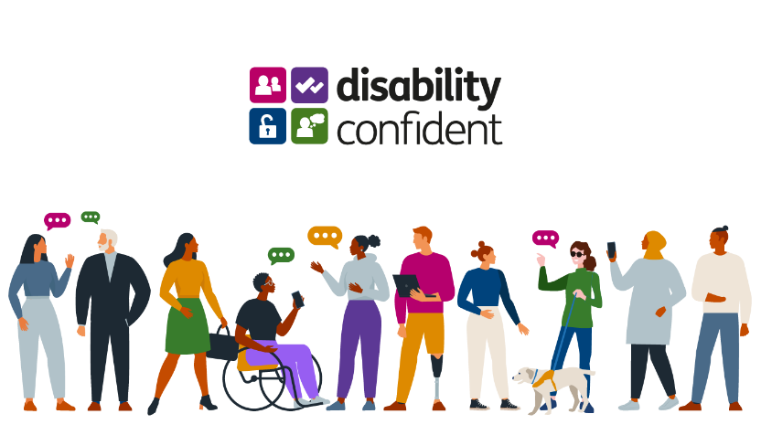

**Scan the QR code below to register for the event...**



**On the day of the event, click the “Join” button..**

**..it’s as easy as that!**

**Support your local community**

**Get Britain Working and Support Disability Confident**

Did you know 23% of the UK adult population has a registered disability or health condition?

Become an inclusive leader in business by attending our online **"Get Britain Working and Support Disability Confident"** event on **Tuesday 11th February** at **10am**.

Tap into the talented pool of people within your local community across **North East and North Yorkshire** and find out how the **Department for Work and Pensions** can support you and your business to build a **diverse, skilled workforce** by **empowering** people with disabilities to **thrive** within the workplace.

Discover the benefits of becoming **Disability Confident** and learn how you can contribute to **Getting Britain Working.**

Don't miss out on this opportunity to make a difference and create a more inclusive society!

