**COVID-19 update**

**17 April 2020**

**In this edition**

* A message from our Clinical Chair, Dr Nigel Wells
* Updates to the RSS COVID-19 webpage

**Attachments**

* None

**A message from our Clinical Chair, Dr Nigel Wells**

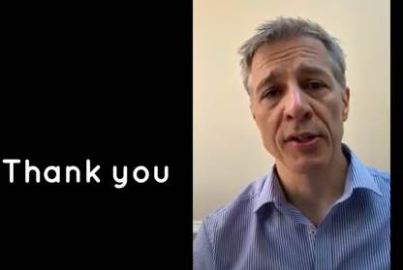

**Our Clinical Chair, Dr Nigel Wells has recorded a video message for all clinicians and staff.  To watch the video message please go to** <https://youtu.be/bjkLkzIHL1g>

**Updates to the RSS COVID-19 webpage**

**PPE**

* [Approval by Health and Safety Executive for use of coveralls as an alternative option for non-surgical gowns](https://www.valeofyorkccg.nhs.uk/seecmsfile/?id=3750&inline=1)
* [Correct use of surgical masks for general practice](https://www.valeofyorkccg.nhs.uk/seecmsfile/?id=3734&inline=1&inline=1&inline=1)
* [Offers made to the CCG for the supply of PPE can be accessed here. Note that these are not endorsed by the CCG.](https://www.valeofyorkccg.nhs.uk/rss/home/infections-and-microbiology/covid-19/ppe-offers/)

**Prescribing and Community Pharmacy updates**

* [Updates from the Regional Drug and Therapeutics Centre](https://www.valeofyorkccg.nhs.uk/seecmsfile/?id=3751&inline=1)
* [Public Health Commissioned Pharmacy Services during the Coronavirus Outbreak - North Yorkshire County Council](https://www.valeofyorkccg.nhs.uk/seecmsfile/?id=3732&inline=1&inline=1&inline=1)

**Provider updates**

* [TEWV COVID-19 Contingency Arrangements](https://www.valeofyorkccg.nhs.uk/seecmsfile/?id=3749&inline=1)
* [York Hospital - COVID-19 Volunteers Pathway](https://www.valeofyorkccg.nhs.uk/seecmsfile/?id=3741&inline=1&inline=1)
* [Public Health GP and Pharmacy Services during the Coronavirus Outbreak - North Yorkshire County Council](https://www.valeofyorkccg.nhs.uk/seecmsfile/?id=3733&inline=1&inline=1&inline=1)

**YORLMC updates**

* [YORLMC update 17 April 2020](https://www.valeofyorkccg.nhs.uk/seecmsfile/?id=3745&inline=1&inline=1)
* [YORLMC update 17 April 2020 (with ACE comments)](https://www.valeofyorkccg.nhs.uk/seecmsfile/?id=3748&inline=1&inline=1)
* [Attachment 1](https://www.valeofyorkccg.nhs.uk/seecmsfile/?id=3744&inline=1&inline=1)
* [Attachment 2](https://www.valeofyorkccg.nhs.uk/seecmsfile/?id=3747&inline=1&inline=1)
* [Attachment 3](https://www.valeofyorkccg.nhs.uk/seecmsfile/?id=3746&inline=1&inline=1)
* [Attachment 4](https://www.valeofyorkccg.nhs.uk/seecmsfile/?id=3743&inline=1&inline=1)

**Useful information**

[Free Mindfulness with York Mind](https://www.valeofyorkccg.nhs.uk/seecmsfile/?id=3742&inline=1&inline=1)