Competitors Guide
We are delighted to announce that after over 600 individuals from across the care sector participated and rose to the challenge in 2022- The North Yorkshire and York Care Provider Olympics is back for 2023 and you are now open to register your provider to take part. This year's running is organised by NHS Humber and North Yorkshire ICB in collaboration with partners from across the area, and will take part between 01 June and 14 July.
This is your chance to get residents and staff up and moving and hold your own Olympic style event to promote the health benefits of physical activity to those in your care. We know that by staying active together we can fight deconditioning syndrome- which can result in reduced mobility and muscle strength, confusion, poor mental health and increased risk of falls. By coming together across the region to celebrate and share ideas on how we can keep residents active which is clinically proven to reduce the risk of major illness by 30%.
You can fill your event full of as many different activities as you like, and consider how you can personalise these to the differing needs of those in our care so we can make sure they are inclusive of all. This is your chance to be as creative as possible, last year we saw everything from wheelchair races to weightlifting and from activities for bed-based residents, staff versus resident rounders and much more!
However as last year we have selected a range of "Medal Events" which providers can take part in, which will count towards our Olympic Medal Table are your chance to compete against fellow providers for our overall Olympic Champions Trophy! All care settings across the county are able to take part.
We will be sharing a weekly Olympic Bulletin throughout the competition so you can keep up to date with how our competitors are taking part, and to share resources, guidance and ideas on how you can promote physical activity in your setting. Our Olympic Closing Ceremony will take place later in July where we will come together to celebrate everybody who took part, and announce our 2023 champions
To register to take part in the fun all you need to do is complete the registration form below and return to sam.varo@nhs.net.

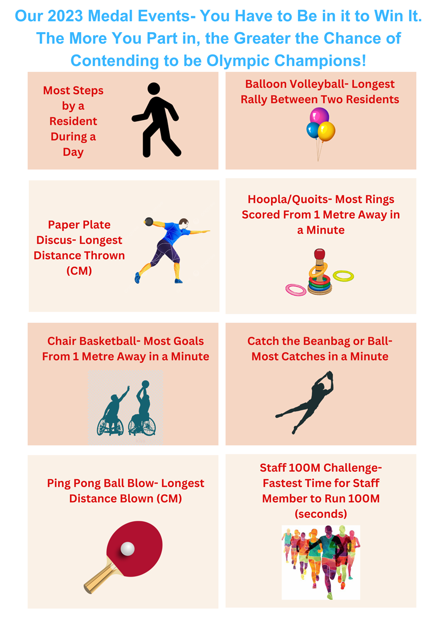

Time to Start Planning Your Event
- Next start training… Limber up and Get in Shape! We will be sharing resources both ahead of and throughout the competition with ideas on how you can support physical activity in your settings.
- Plan your day- Spark the excitement, get busy making decorations such as banners/flags/bunting. Consider a team mascot, an Olympic torch, a podium?
- Is there anyone that you can involve such as a local school or a sports personality?
- Do you have any sports men/women in your organisation, celebrate and tell their stories?
- Plan your games or races – Get creative with wacky wheelchair races, zimmer frame races, egg and spoon, dressing up, obstacle races, carpet bowls… Anything goes! Consider how you can personalise these to the needs of your residents.
- Consider a creative way of ensuring all participants maintain hydrated throughout. Follow this link for more information on our Improving Hydration in Care Settings Project for some great ideas.

2023 North Yorkshire and York Care Provider Olympics Registration Form
Name of Care Provider
Older Adults or Younger Adults/LD Category
Team Name
Contact Name
Date of Event (Between 01 June and 14 July)
Please Return to sam.varo@nhs.net

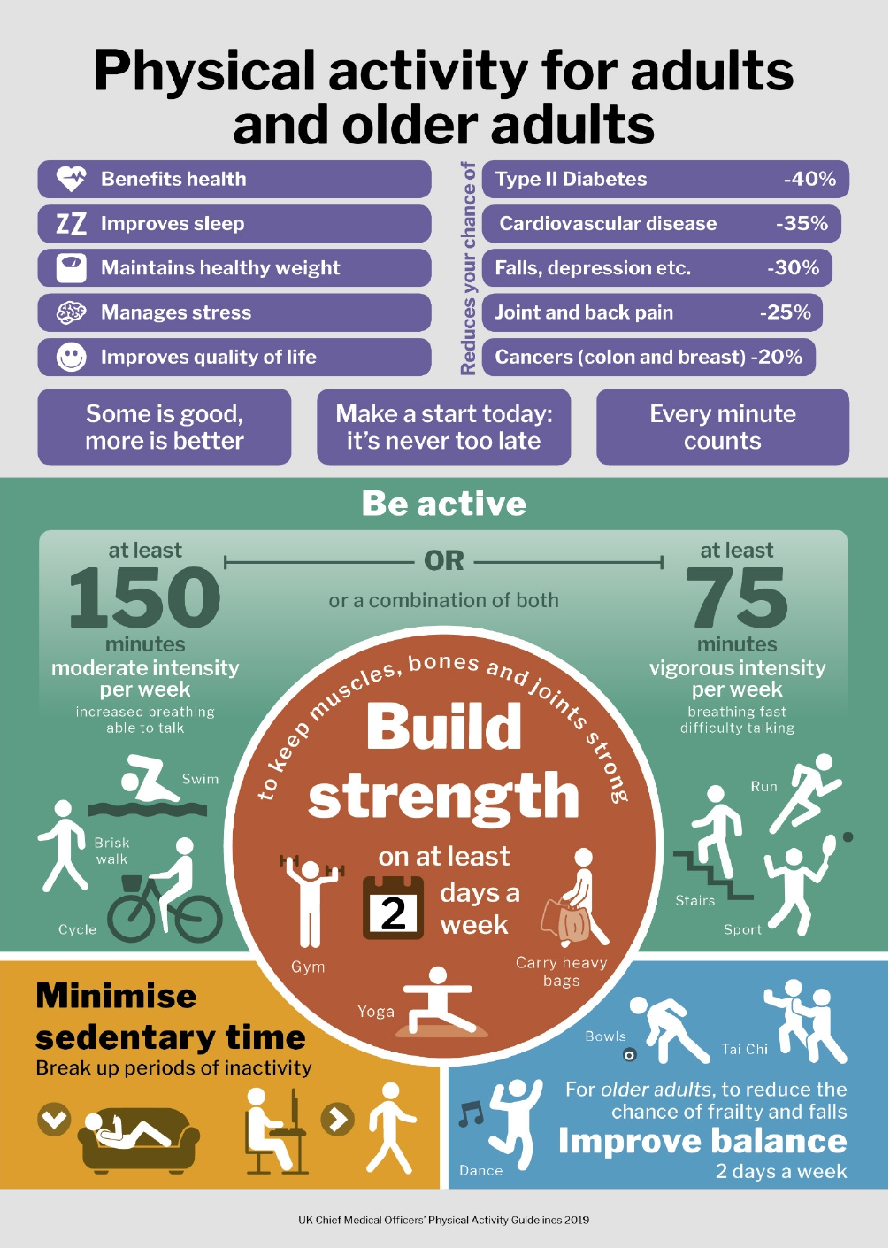
Completed Your Event? Please Record Your Scores into The Below Table and Return to sam.varo@nhs.net
Date of Event
Number of Residents Who Took Part
Number of Staff and Other Individuals Who Took Part
Most Steps by a Resident During a Day
Balloon Volleyball- Longest Volley Between Two Residents (Number of Passes)
Paper Plate Discus- Greatest Distance Thrown (CM)
Hoopla/Quoits. Most Rings Scored from 1M Away During a Minute
Chair Basketball- Most Goals from 1M Away During a Minute
Catch the Beanbag or Ball- Most Catches in a Minute
Ping Pong Ball Blow- Longest Distance Blown (CM)
Staff 100M Challenge- Fastest Time for Staff Member to Run 100M (Seconds)

We would love to see your photos from your day and share them with other providers! Remember to get consent from all who appear before sharing. Landscape photos are preferred where possible.

