York and North Yorkshire Mayoral election 02.05.24
Comms toolkit to help share voter information with people assessed as requiring social care support
We are promoting a campaign to raise awareness of the different ways people can cast their vote in the above and other elections, and to make them aware of the key dates for the mayoral election which are:
- register to vote by 11.59pm on Tuesday 16 April 2024
- apply for a postal vote by 5pm on Wednesday 17 April 2024
- apply for a proxy vote or free voter ID by Wednesday 24 April 2024
- polling day on Thursday 2 May 2024 (7am to 10pm)
These dates will also be shared in a candidate address book, which is an A5 24-page leaflet which, by law, must be mailed to every registered voter in York and North Yorkshire. It will be sent out in April and includes details of how you can cast your vote and addresses from the candidates who have chosen to submit an address.
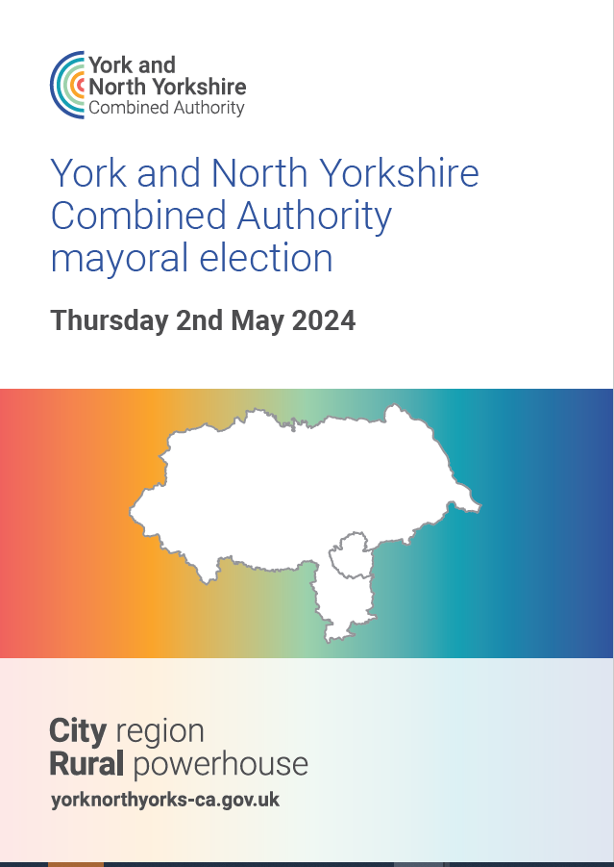
To help promote the campaign this toolkit provides information to help support people who are assessed as requiring social care support to vote in the first York and North Yorkshire Mayoral election on 2nd May 2024.

Please share this with your staff, partners and networks so that the messages can be amplified across the county.
How you can help
This toolkit is aimed at:
All adult social care colleagues (including NYC social workers and care homes), care providers, public health colleagues, external health partners, Learning Disability Board and any other groups of voters that can be supported by HAS colleagues.
As colleagues and partners who work with groups who may need extra support with voting, please help us by sharing the details of ways to vote in the election through your communication channels with your networks, groups, and contacts. This toolkit is designed to help provide content for you to share if possible – in it you will find wording to copy and paste, and images to use.
We will strive to provide voter information specifically about the mayoral election in any format that is requested (i.e., braille, BSL, audio etc) to facilitate people to vote.
Please email elections@northyorks.gov.uk to request accessible formats, and marketing collateral.
IF THERE IS ANYTHING ELSE THAT WOULD BE USEFUL TO HELP YOU SHARE THIS CAMPAIGN, PLEASE GET IN TOUCH VIA THE ABOVE EMAIL ADDRESS.
This toolkit includes:
1. Newsletter/ bulletin/ email copy
- Social media post copy and images
- Supporting video featuring Christopher Porter - Self Advocate
- Supporting information
- Your right to vote information leaflet for people living in our care homes
- Slide deck for care providers
- Easy read guide to filling in a ballot paper
- My Vote My Voice resources
- Promote the Vote: A BASW practice ‘How to’ guide to support adults with learning disabilities to vote
Thank you for your helping to share our campaign. If you have any questions, please email elections@northyorks.gov.uk
- Newsletters/ bulletins/ email copy
Please copy the text and link and drop it into your email or newsletter directly without making any changes to the link. This helps us to understand how many people are reading these messages

The York and North Yorkshire Mayor will be chosen by you in the first York and North Yorkshire Mayoral election on Thursday 2 May 2024.
The Mayor will lead the York and North Yorkshire Combined Authority – a Combined Authority is where a group of councils work together across a larger area – in our case, the city of York and North Yorkshire.
The mayor will have £540 million to be spent over the next 30 years.
The Mayor and Combined Authority will have powers and responsibilities that used to be held by central government. This includes improving the supply and quality of housing and funds to improve transport.
You must be registered to vote in this election by 16 April 2024.
Find out if you are registered and how to vote at https://www.northyorks.gov.uk/mayoralelection
You can cast your vote however it suits you – in person, by post or by proxy, which is when you identify someone to vote on your behalf.
If you are voting in person you will need to bring a Photo ID to your polling station. You can make sure you have an accepted form of identification here, https://www.northyorks.gov.uk/your-council/elections-and-voting/how-vote
If you don’t have an accepted form of identification, you can apply for free voter ID by 5pm on Wednesday 24 April. Apply for free voter ID here: https://www.gov.uk/apply-for-photo-id-voter-authority-certificate
You can vote from home if you can’t or don’t want to go to your polling station on election day. Registering to vote by post is easy - you’ll simply need to prove your identity. Apply for a new postal vote or cancel an existing one, before the deadline of 5pm on Wednesday 17 April at https://www.northyorks.gov.uk/your-council/elections-and-voting/apply-postal-vote
You can apply for a trusted friend or family member to cast your vote by proxy at your polling station at https://www.northyorks.gov.uk/your-council/elections-and-voting/apply-proxy-vote
Apply for a proxy vote for this election before the deadline of 5pm on Wednesday 24 April.
You can also call 0300 131 2 131 (please say ‘Election’ when prompted) to request information about how to vote.
Accessible formats are available on request.

- Social media copy

Facebook and X social media messages
Social media posts to use on your channels to publicise ways to vote in the York and North Yorkshire Mayoral election on 2 May 2024 and deadline for registration.

Use these messages up to and including Tuesday 16 April

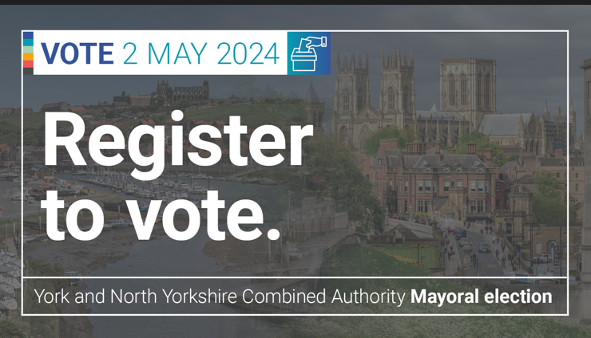  Please add this image to your message from the folder attached to the email – the file is called  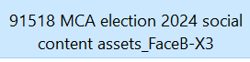  Please copy the text and link and drop it into your social message directly without making any changes to the link. This helps us to understand how many people are reading these messages. | Facebook version  The York and North Yorkshire Mayor will be chosen by you in the election on Thursday 2 May 2024.  You must be registered to vote in this election by 11.59pm on 16 April  Find out how to register at:  www.northyorks.gov.uk/mayoralelection  #GetReadyToVote #YourVoteMatters  -------------------------  X (formerly Twitter) version:  The York and North Yorkshire Mayor will be chosen by you in the election on Thursday 2 May 2024. You must be registered to vote in this election by 11.59pm on 16 April. Find out how to register at www.northyorks.gov.uk/mayoralelection #GetReadyToVote #YourVoteMatters
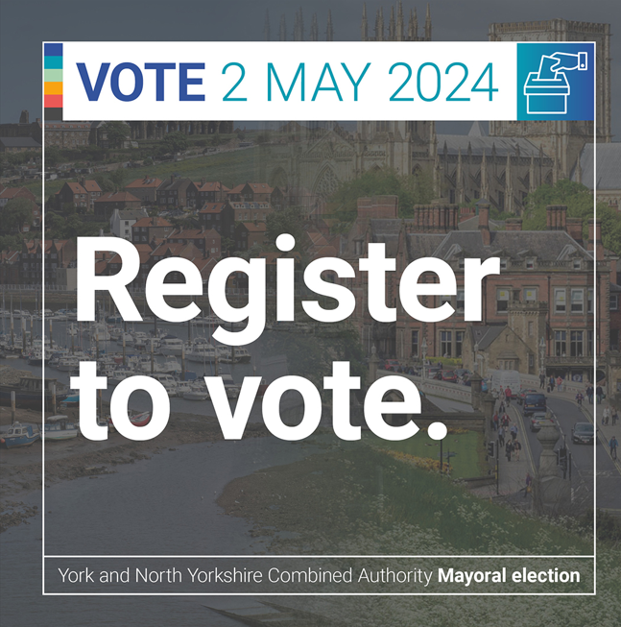  Please add this image to your message from the folder attached to the email – the file is called  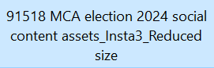 | Instagram version  The York and North Yorkshire Mayor will be chosen by you in the election on Thursday 2 May 2024.  You must be registered to vote in this election by 11.59pm on 16 April  Find out how to register at:  www.northyorks.gov.uk/mayoralelection  #GetReadyToVote #YourVoteMatters
Use these messages up to and including Thursday 2 May

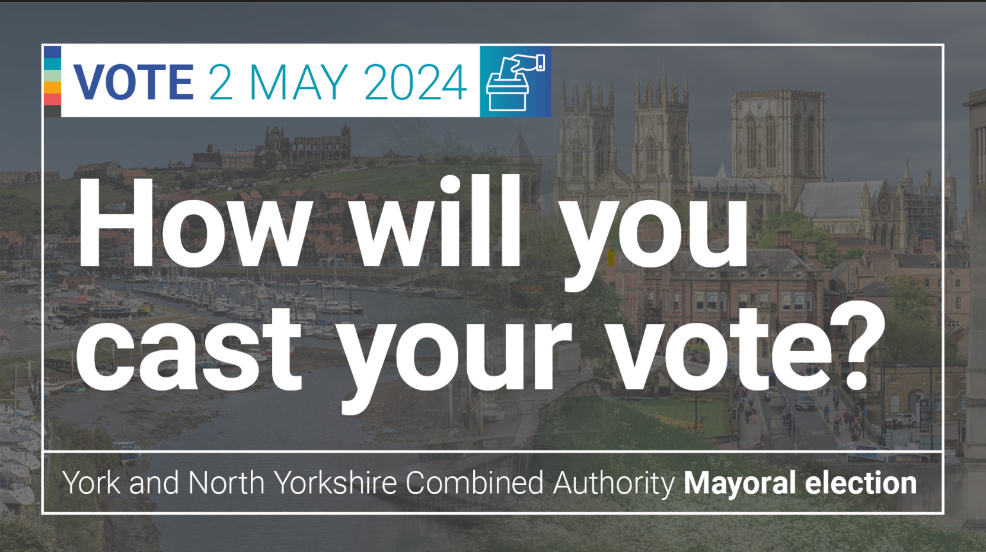  Please add this image to your message from the folder attached to the email – the file is called  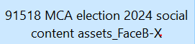  Please copy the text and link and drop it into your social message directly without making any changes to the link. This helps us to understand how many people are reading these messages. | Facebook version  How will you cast your vote at the York and North Yorkshire Mayoral election on 2 May 2024?  You can vote however it suits you – in person, by post or by proxy.  Find out how to arrange the way you want to vote at: www.northyorks.gov.uk/mayoralelection  #GetReadyToVote #YourVoteMatters  -------------------------  X (formerly Twitter) version:  How will you cast your vote at the York and North Yorkshire Mayoral election on 2 May 2024?  You can vote in person, by post or by proxy.  Find out more at www.northyorks.gov.uk/mayoralelection
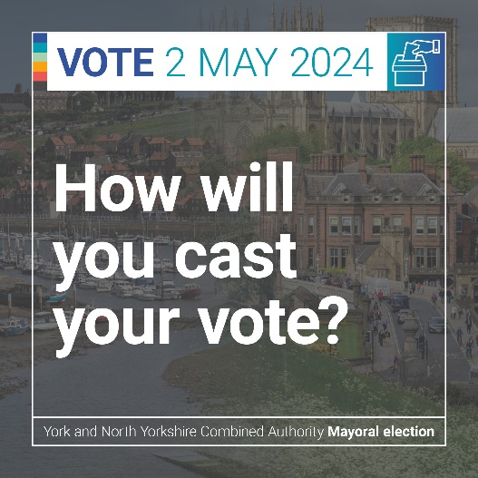  Please upload this image from the folder attached to the email – the file is called  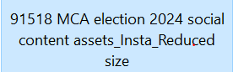 | Instagram version  How will you cast your vote at the York and North Yorkshire Mayoral election on 2 May 2024?  You can vote however it suits you – in person, by post or by proxy.  Find out how to arrange the way you want to vote at:  https://www.northyorks.gov.uk/mayoralelection  #GetReadyToVote #YourVoteMatters

3. Supporting video of Christopher Porter – Self Advocate
Christopher has kindly given us permission to use his video for this campaign – it can also be shared with partners – details are below.
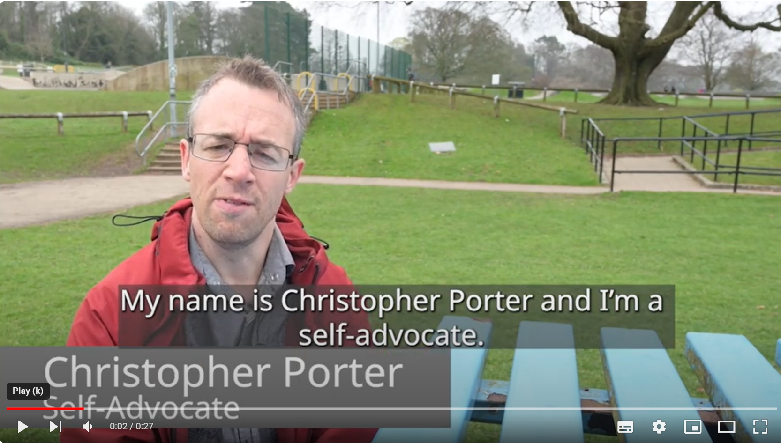

There are two ways you can access the video to use on your channels:
- YouTube link to the video is here https://youtu.be/TBdQ3-K54p8 (the video is unlisted, but it will work on social media if you want to use the video in a social media post)
- Alternatively, the video file to download and use on your channels is here:
https://we.tl/t-HFtrgxMqVG
(please contact alison.clarke@northyorks.gov.uk if this link doesn’t work – it is a wetransfer link and not all organisations can acess depending on your firewall)

The video can be used in whatever context you feel it would work best:
- As part of a presentation
- On social media (see below)
- In a one to one or group situation

Suggested social media message:

Use this suggested message up to and including Tuesday 16 April
The video can be used any time up to 2nd May.

Use your vote!
The York and North Yorkshire Mayor will be chosen by you in the election on Thursday 2 May 2024.

You must be registered to vote in this election by 11.59pm on Tuesday 16 April.

Find out how to register at:
www.northyorks.gov.uk/mayoralelection

#GetReadyToVote #YourVoteMatters

- Supporting information

Printed information and accessible formats of voter information
Please email elections@northyorks.gov.uk to request braille, easy read (available after 8 April), large print and any other formats of the candidate address book.

Your right to vote information leaflet for people living in our care homes – distributed by Emily Smales and Wendy Macdonald
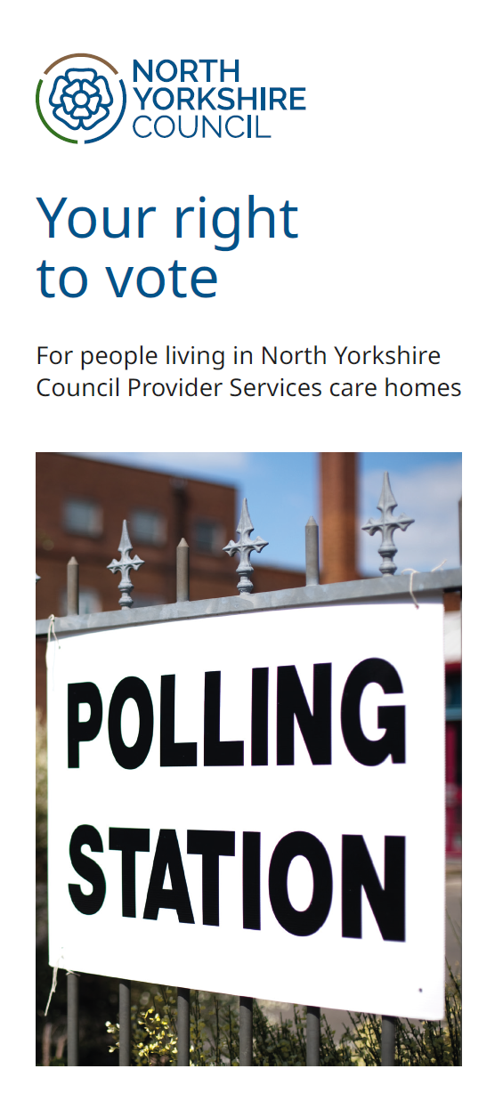

- Slide deck to share in meetings can be downloaded from the sharepoint site
- Voter information and advice on how to support people to vote is also available on the my vote my voice website https://www.myvotemyvoice.org.uk/about/
  - https://www.myvotemyvoice.org.uk/voting/quick-guide-to-voting/
  - Supporting voters – My Vote My Voice

- Promote the Vote: A BASW practice ‘How to’ guide to support adults with learning disabilities to vote.
https://new.basw.co.uk/policy-and-practice/resources/promote-vote-basw-practice-guide

Easy read guide to filling in a ballot paper.
