

LEARNING DISABILITY LIAISON SERVICE - REFERRAL

Person Referred
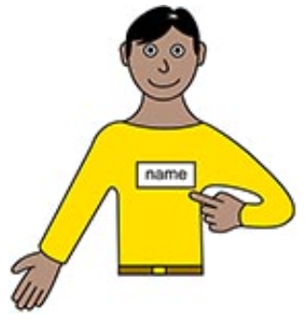  Name: | Forename  Surname |   Date of Birth |  |  |  | Date of birth
Address   | Patient address |   Telephone Number |  |  |  | Patient preferred telephone
 | Patient address | NHS Nº (If known) |  |  |  | NHS number
Main Contact (Family, Carer, Care provider)
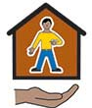  Name | Next of kin | Telephone Number |  |  |  | Next of kin's telephone
Address | Next of kin's address | Relationship  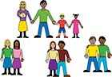
Person Making This Referral
Name   | Referrer name | Telephone Number |  |  |  | Registered GP phone number
Address | Registered GP address | Relationship
Does the person or their family / carers know about this referral?  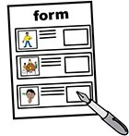 |  |   Who is the best person to speak to about this referral?
Reason For Referral
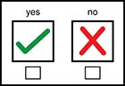
Does the person have a hospital appointment?
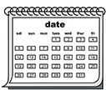
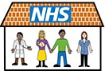
Yes
No

When? |  |  | Where?  
About the patient
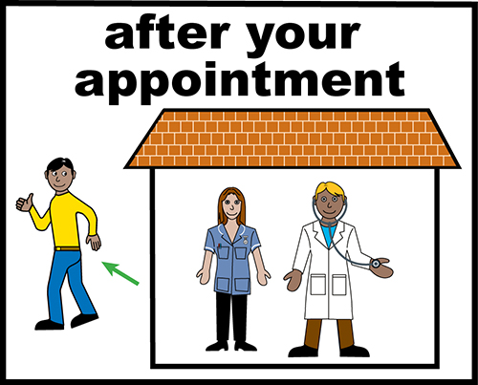
How does the person communicate? |  |  |  | Other professionals involved  ####


Other useful information:
(Medical history, current social circumstances, previous treatment, specific behaviours. Please forward any reports/documents that may be useful.


Please send completed forms to

Jo Blades
Learning Disabilities Liaison Nurse


Malton Hospital
Middlecave Road
Malton
North Yorkshire
YO17 7NG



jo.blades@york.nhs.uk

07795 126473

