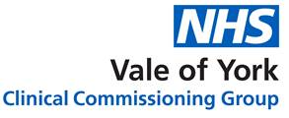
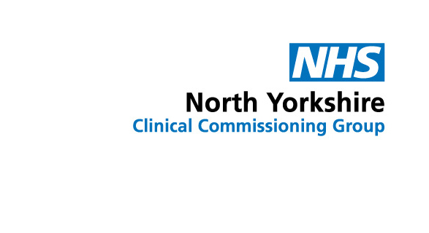

The North Yorkshire and York CCGs LeDeR Programme Annual Report 2021

1st April 2020 – 31st March 2021

(Easy Read version)

Authors and Contributors:
Allison Brown Specialist Practitioner for LeDeR and Local Area Contact; NHS North Yorkshire CCG

Julie McGregor Program Director Transformation; NHS North Yorkshire CCG

Samantha Rigg Project Administrator, Adult Safeguarding; NHS North Yorkshire CCG

Contents
Page
Some difficult words we use | 3-5
Introduction | 6
Deaths we have has been told about | 7
Covid-19 | 7-10
Hospital deaths | 10
The causes of deaths of people with learning disabilities | 11
The quality of care given to the people who died | 12-13
What we think needs to change | 14-15
Thank you | 16

Some difficult words we use (these words are in bold the first time they are used)
LeDeR | Learning Disability Death Review – we used some of the first letters of each word to make the name ‘LeDeR’. Reviews are of people from 4 years of age.
Average age | To work out the average age we add up all the ages of everyone who has died. Then we divide that number by the number of people who have died.
Do Not Resuscitate | If doctors think a person’s heart could not be re-started, they fill in a Do Not Resuscitate form.
Liaison | A Learning Disabilities Liaison Nurse makes sure you get all the information and help you need if you go into hospital.  They also make sure the hospital staff gets all the information they need to care for you.
Pneumonia | An infection in the lungs making breathing more difficult. It is caused by bugs called ‘bacteria’.
Aspiration Pneumonia | An infection in the lungs caused by food or drink going down ‘the wrong way’.
Sepsis | An infection that affects the whole of the body.
Constipation | Is when you find it hard to poo.
Reasonable adjustments | Making changes to how services do things to make sure people with learning disabilities can use the services.
Review | A check on a person’s death.
Reviewer | Someone who checks up on a person’s death.
Cancer Screening | Screening can detect a problem early, before there are any symptoms.
Care packages | What is needed for someone to stay healthy.
Avoidable causes of death | Deaths that could be stopped by good healthcare.
Advocate | Advocacy is about helping you to speak up and get the support you need.
Best Interests | If someone is not able to make a decision, then the people helping them must only make the decision in the way they think the person would make it if they could.
Annual | Every year.
The Mental Capacity Act | The Mental Capacity Act is all about making decisions. It is a law about making sure that people have the support they need to make decisions. If a person is not able to make a decision, it says what should happen.
CCG (Clinical Commissioning Group) | An NHS organisation who plan and pay for your healthcare.
COVID -19 | Is an infection that causes problems mainly with peoples breathing. It is spread from person to person. Some people with coronavirus have to go into hospital. Some people in the hospital need to use a special device called a mechanical ventilator to help them breathe many people worldwide have died from the infection.
Annual Health Check | An Annual Health Check is done by your Doctor once a year for anyone is 14 years old and over. Your doctor will take a closer look at how you are doing – making sure you are healthy.

- Introduction

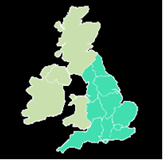
This is the third LeDeR Annual Report written for the North Yorkshire and York CCGs. The LeDeR programme was set up to help improve services for people with learning disabilities as well as stop people with learning disabilities dying too soon.

Everyone with a learning disability in England, including North Yorkshire referred to LeDeR, has their death looked at in the same way.

Every death has a first check. We call this an ‘Initial Review’.

- Deaths we have has been told about
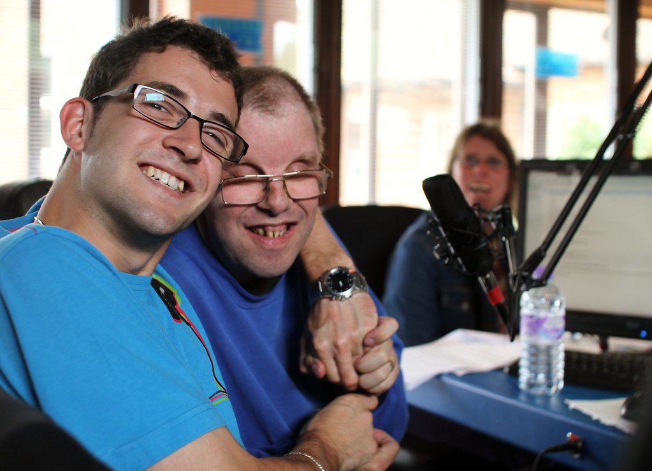
Sadly, 55 deaths of people with a learning disability in North Yorkshire were reported to us.
The average age at death in North Yorkshire was 66.2 years (60 years 2019-2020). The average age at death in England was 59 years. In North Yorkshire half were female and half male.

- Covid-19
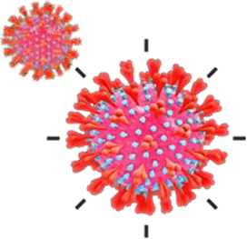
2020 was an unusual year because of the Covid-19 virus. So, we need to be careful comparing how things were in 2020 with the other years. A larger number of people with learning disabilities died from Covid-19 than people in the general population. People with learning disabilities who died from Covid-19 also were younger than people in the general population.

Lots of people who have Covid-19 have the same problems – we call these ‘symptoms’ of having the illness.

NHS England advises that the main symptoms of the illness are:

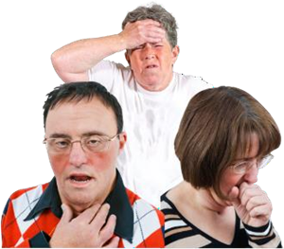

- A fever (high body temperature).

- A Cough.

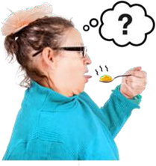

- Not being able to smell or taste things

Problems were found with how the services providing support worked.
These problems included:
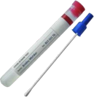

- The arrangements for Covid-19 testing and protecting patients from catching the virus.

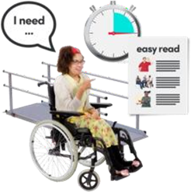

- Services not making reasonable adjustments for people with learning disabilities.



- Confusion about national guidance about protecting people from Covid -19.

The concerns were mainly about:
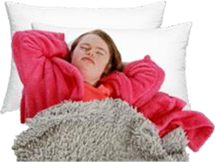

- Not stopping Covid -19 from spreading.

- Not recognising signs that a person’s health was becoming worse

- Hospital deaths

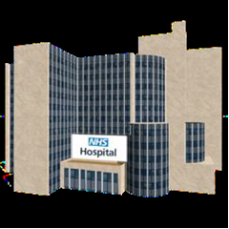
Hospital deaths in North Yorkshire increased from last year. This was because of Covid -19 infections. In the rest of England, most people died in hospital.

- The causes of deaths of people with learning disabilities

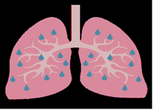

In North Yorkshire, the most common cause of death was Covid -19. The second most common cause of death was pneumonia.

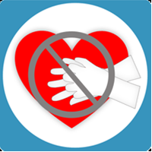
Sometimes Doctors cannot restart a person’s heart if it stops. This is not possible if the person is too ill. If doctors think a person’s heart could not be restarted a doctor signs a form. This is called a Do Not Resuscitate form. Most of the Doctors in North Yorkshire filled this form in correctly.

- The quality of care given to the people who died

Nearly all our Reviews found the person had received expected or good care. Nobody died because of poor care.

Reasonable adjustments were made to make sure the person’s care was right for them.

This was because: -

- Hospital Passport.
- Hospital records had flags on the system so staff knew that the person had a learning disability.
- The Hospital Learning Disability Nurse supported a person if they were in hospital.
- Relatives or carers attended health appointments with the patient.
- Easy Read health information.
- Single rooms when someone was in hospital.
- Being cared for by someone who knew them whilst in hospital.
- End of hospital clinic appointments for longer times.
- Emergency Admission to Hospital packs.

Sometimes there were problems with how services supported people, this was because:

- Cancer screening had not been completed.
- Services did not know the person had a learning disability.
- Services did not know how to help people with a learning disability.
- Failure to know when someone had a Covid -19 infection early enough to prevent spread amongst residents and staff.
- Advise as to how to live healthily including how to lose weight was not always given by health staff.
- Staff did not always know when someone was becoming very unwell.
- Annual Health Checks are not always been carried out with everyone who has a learning disability.
- Not using the Mental Capacity Act properly.

- What we think needs to change

We met with local families and with local services when we did the North Yorkshire Reviews. Together, we had some ideas about how to make things better for people with learning disabilities.

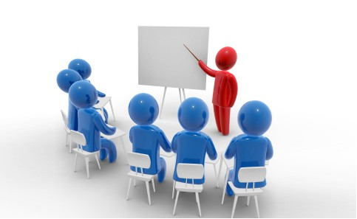
Some of these were:

Training staff how to better support people with learning disabilities.

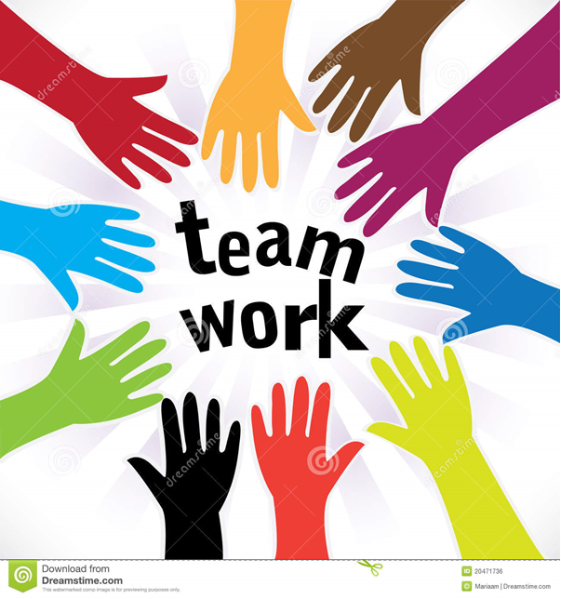

Services need to work together better

We need to reduce the number of Covid -19 deaths


GPs should know who has a learning disability and offer an Annual Health Check and cancer screening at the right time.


Health and Care staff need to be able to see when someone with a learning disability is becoming unwell and make sure the person is seen quickly by a Doctor.

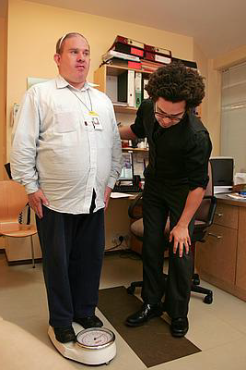

GPs need to offer help to lose weight if a person is overweight.

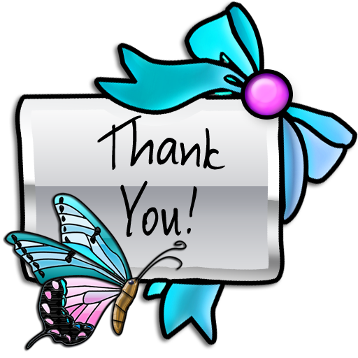

Thank you to the local families, friends and carers of the people who died who are loved and missed. Also, to the local services who talked to us. They helped us with ideas for how to improve things for people with learning disabilities in North Yorkshire.
Thank you to Christopher Porter for his proof reading of this document.

