To all General Practices  NHS Vale of York CCG | West Offices  Station Rise  York, Y01 6GA  Y01 6GA  Tel: 01904 555870  RNID typetalk: prefix-18001  Email: valeofyork.contactus@nhs.net  Website: www.valeofyorkccg.nhs.uk
 | 17 March 2020
Dear colleagues

Re: Update on Novel Coronavirus (2019nCoV)

Key messages

- Update on the number of cases
- Standard COVID19 messages to be used by practices
- COVID-19 and Information Governance

Thank you for all your hard work. It is an extraordinary time we are living in and we are facing perhaps the greatest public health threat in a generation. We will need to continue to be flexible in our responses and keep focused on our priorities to:

- Save lives
- Protect the vulnerable
- Keep healthcare going and protect staff

I know that already practices have changed systems and updated protocols in order to triage and stratify risk for patients with respiratory illness whilst balancing the healthcare needs of our residents. Practices will continue to divert patients away from hospital where possible and reduce risks to fellow patients and staff, thus allowing secondary care to concentrate on those needing high intensity support. Primary care excels at flexibility and agility at local neighbourhood levels.

We must continue to make sure that vulnerable patients and patients with a health need can access services and that our measures are proportionate going forwards. We must avoid patients falling through cracks. There will be growing public anxiety, fear, even panic in the coming weeks. And, we must be there for the public.

1. Update on the number of cases

To date, there are 6 confirmed cases of COVID19 in North Yorkshire and 4 in York (as of 9am on 16/3/20). Compared to other parts of the country, this is a relatively low number.

2. Standard COVID19 messages to be used by practices
NHSE have asked that every GP surgery use the following text without exception. Updated versions will be posted on this webpage as things change. I know some of you will have added messages around total triage and local system working.
Telephone message
Please do not book a GP appointment or attend your GP Practice if you have symptoms associated with coronavirus including a new continuous cough and a high temperature.

You are advised to stay at home for 7 days.

If your symptoms are serious, or get worse, NHS 111 has an online coronavirus service that can tell you if you need further medical help and advise you what to do.

Only call 111 direct if you cannot go online, or are advised to do so by the online service.

For the latest COVID19 advice please visit www.nhs.uk/coronavirus.

Online booking
If you have symptoms associated with coronavirus including a new continuous cough and a high temperature, you are advised to stay at home for 7 days. Do not book a GP appointment or attend your GP Practice.

If your symptoms are serious, or get worse, NHS 111 has an online coronavirus service that can tell you if you need further medical help and advise you what to do.

Only call 111 direct if you cannot go online, or are advised to do so by the online service.

For the latest COVID19 advice please visit www.nhs.uk/coronavirus.

SMS
For the latest COVID19 advice please visit www.nhs.uk/coronavirus.
Coronavirus advice: if you have a new continuous cough and/or a high temperature, please stay at home for 7 days. Do not go to a GP surgery, pharmacy or hospital. If your symptoms are serious, or get worse, visit the NHS111 online service.
- COVID19 and Information Governance

The health and social care system is going to face significant pressures due to the COVID19 outbreak. Good information governance should enable health and care staff to manage and share information in a way that puts the interests of the people they are caring for and the wider public first. In the current circumstances it could be more harmful not to share health and care information than to share it. The Information Commissioner’s Office has issued a statement and published a Q&A resource to reflect this position and health regulators have also published a joint statement.

I note with thanks the letters and clarification from the LMC and NHSE today; I attach a FAQ and an update from Shaun Macey around IT.

We are talking with all local system partners across local authority, education and private healthcare providers to free up any clinical capacity for the coming months. I will update you as soon as possible on practical implications for primary care.

Finally I would urge you with the new guidelines around isolation to continue to refresh your emergency plans and discuss staffing resilience and options with your neighbouring practices and within PCNs.

With best wishes
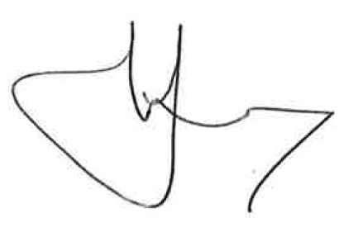
Dr Nigel Wells
Clinical Chair

