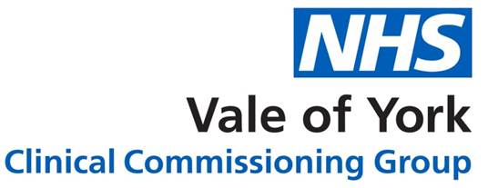
Primary care rebate schemes
Start date | Company | Products Involved
01/2017 | Ethypharm UK Ltd | Fencino Patches
06/2017 | Aspire Pharma Ltd | Biquelle XL
06/2017 | AYMES International Ltd | AYMES Complete Oral Nutritional Supplements
12/2017 | Daiichi Sankyo UK Limited | Lixiana
01/2018 | GSK | Seretide, Evohaler and Accuhaler
02/2018 | Sanoffi-Aventis | Clexane Injection
09/2018 | Merck, Sharpe and Dohme Limited | Januvia
01/2019 | Sandoz | Mezolar Patches
02/2018 | Intrapharm Labs | Aquamax Cream
07/2019 | Chiesi | Clenil
07/2019 | QDEM | Longtec

Updated July 2019

